This assignment we utilized LVM to create a new vda3 partition from the available space within /dev/vda to expand the system root filesystem’s usable disk space as a physical volume. After the expansion is complete the Chrony NTP service is installed and properly configured to allow for time synchronization, and the firewall is updated to allow NTP services and whitelists udp port 123. Last EPEL repository packages are installed allowing for the following installation of several tools that make use of it. The following commands were used to accomplish this:
df -h / shows the total size, usage and available space of the root filesystem, this is to record the current filesystem size before it is expanded by the creation of the new partition.
fdisk /dev/vda opens the fdisk partitioning utility for disk /dev/vda.
The following inputs are used to create a new partition:
- n creates a new partition.
- p specifies the new partition will be a primary partition.
- 3 assigns the partition to 3, becoming /dev/vda3.
- Pressing enter twice sets the default values for the first and last sectors, so the partition will use all remaining free space on the disk.
After the partition is created, additional commands are used to change its type and save the changes made.
- t changes the type of a partition.
- 3 selects partition 3 to have its type changed.
- 8e sets partition 3’s type to Linux LVM
- w writes the changes to the disk and exits fdisk
partprobe updates the kernel’s view of the partitions so the operating system aware of the changes made to partitions without having to reboot.
pvcreate /dev/vda3 initializes the new /dev/vda3 partition as a LVM physical volume.
vgextend cs /dev/vda3 adds the /dev/vda3 physical volume to the centos (cs) volume group increasing its storage.
vgscan scans for LVM volume groups and updates the system’s cache accordingly.
lvextend -l +100%FREE /dev/cs/root extends the root volume by appending all available space of the cs volume group.
xfs_growfs / grows the filesystem mounted at / to utilize the new space from the now extended volume.
df -h / is called again to ensure the partition is accounted for in the disk size. We can tell it worked by the total size and available space being larger.
dnf -y install chrony installs chrony, a NTP to keep the system’s clocked synchronized with other time sources.
systemctl enable chronyd --now enables chronyd to start automatically on system boot, the --now portion also tells it to start immediately instead of waiting for the next boot.
nano /etc/chrony.conf opens chronyd’s configuration file in an editor, in this editor we do the following:
- Comment out all lines beginning with “pool” or “server,” this is to ensure the system will only synchronize with the servers we specify.
- Add server 147.64.243.110 iburst specifying a specific NTP server for the system to synchronize time with, iburst speeds up the synchronization process for the initial sync.
- Before making further changes, we save and exit out the editor and restart Chronyd with systemctl restart chronyd to apply the changes.
- Add allow 10.0.0.0/8 this allows other systems in the 10.0.0.0/8 network to query the computer’s NTP server to synchronize time with it.
- Again, Chronyd is restarted to apply changes.
firewall-cmd --zone=public --add-service=ntp updates the firewall and enables it to allow NTP traffic.
firewall-cmd --zone=public --add-service=ntp --permanent makes the change persist between restarts of the firewall and system.
firewall-cmd --zone=public --add-port=123/udp updates the firewall to allow network transmissions from the udp port 123.
firewall-cmd --zone=public --add-port=123/udp --permanent like with the ntp service makes the added port persist between restarts.
firewall-cmd --reload is used to restart the firewall ensure the changes are properly saved and applied.
dnf -y install epel-release installs the EPEL repository package, providing the resources for further installations.
dnf -y install htop bc jq atop installs multiple tools that assist in system management utilizing the EPEL repositories, htop and atop are for process monitoring, bc allows command-line calculations, and jq enables parsing and processing JSON.
dnf -y update updates all installed packages ensuring the system is fully up to date.
Finally, a system reboot is performed so any updates relating to the kernel or services take effect. After a final check that the changes made work as intended the tasks are complete.
With the tasks completed we can check the specifications, names, and sizes of each disk, partition, disk group, and logical volume using the following commands:
lblsk shows a list of disks, partitions, and mount points
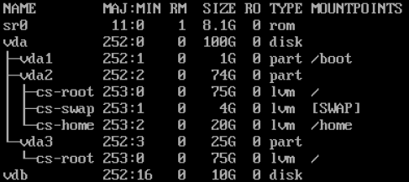
fdisk -l shows partition sizes and types
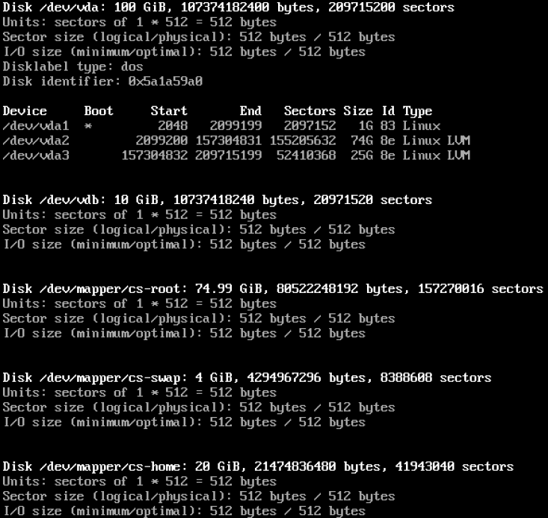
pvs shows LVM PVs with their sizes
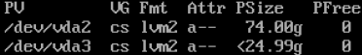
vgs shows LVM VGs with their sizes
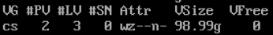
lvs shows LVM LVs with their sizes
